Inverters

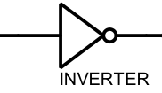

Size: 2 units
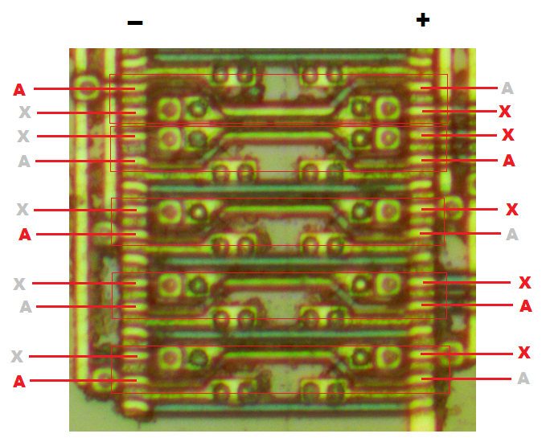

Nand 2
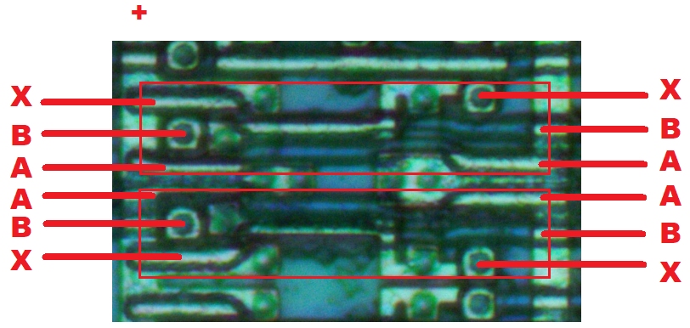
Nand 3
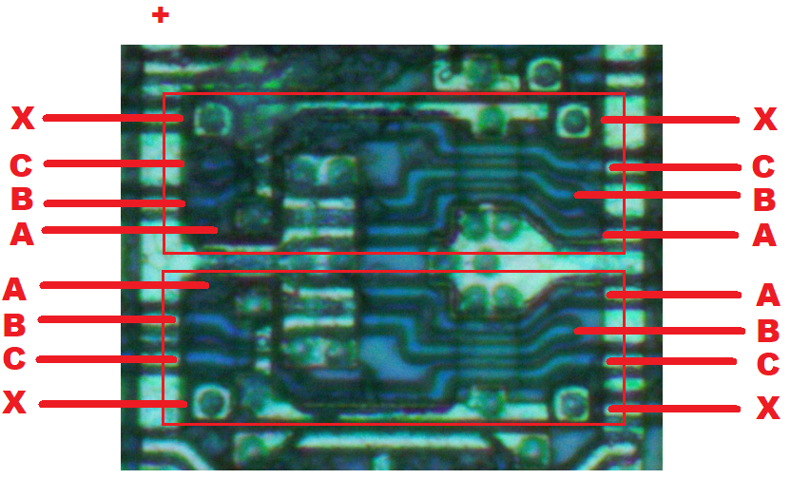
Nand 4
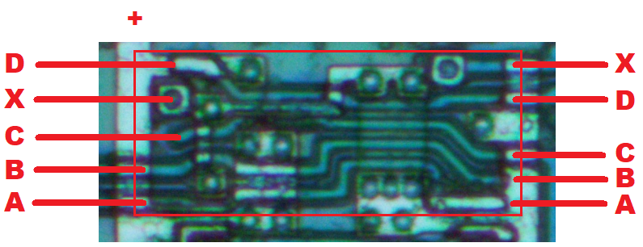

Nand 5
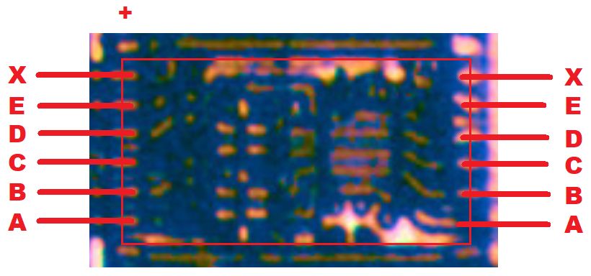
Nand 7
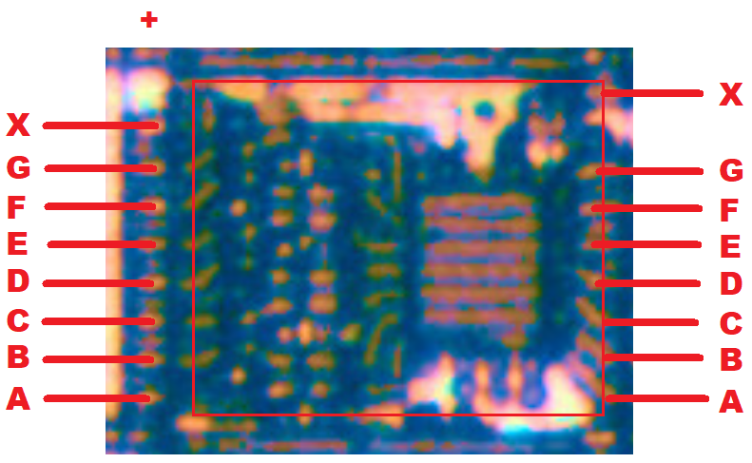
Nand 8

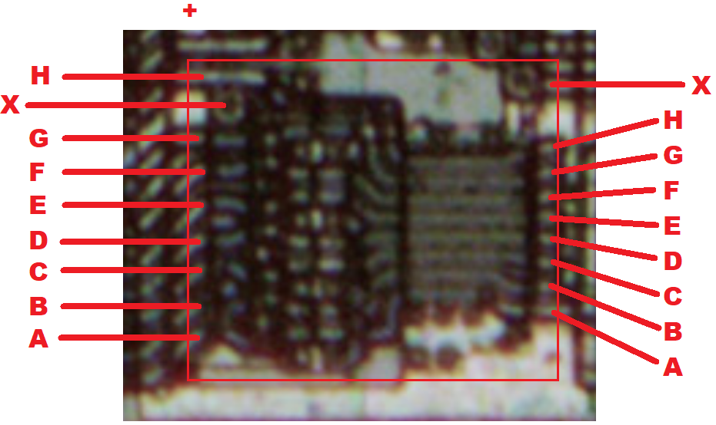
Notice: Large Square Block is on the - side.

Nor 2
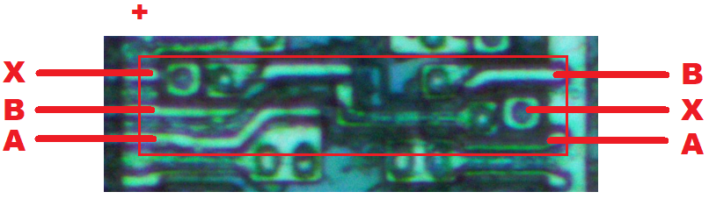
Nor 3
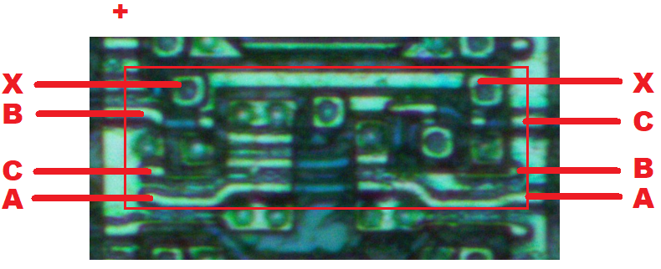
Nor 4
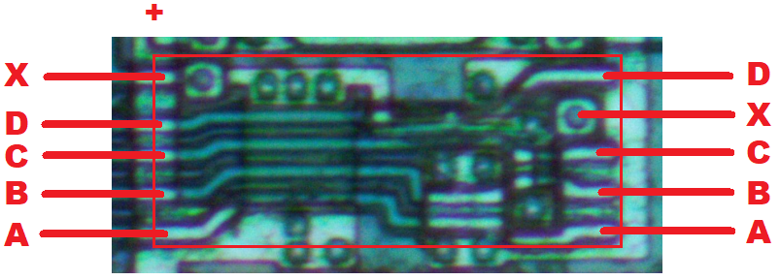
Nor 5
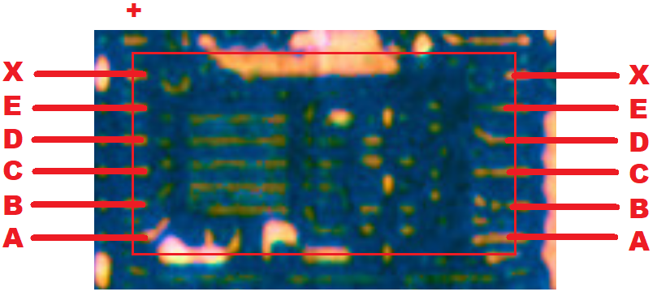
Nor 6
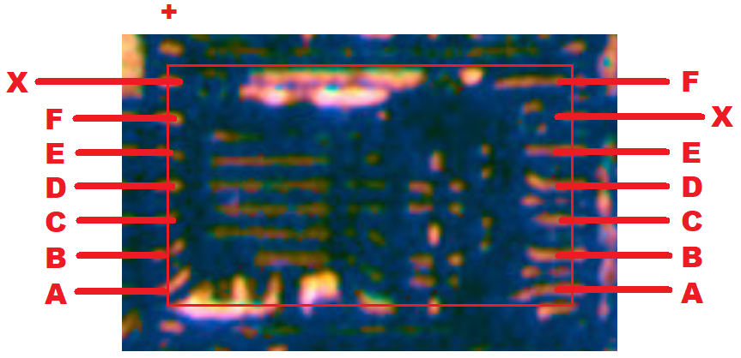
Notice: Large Square Block is on the + side.

XNor 2

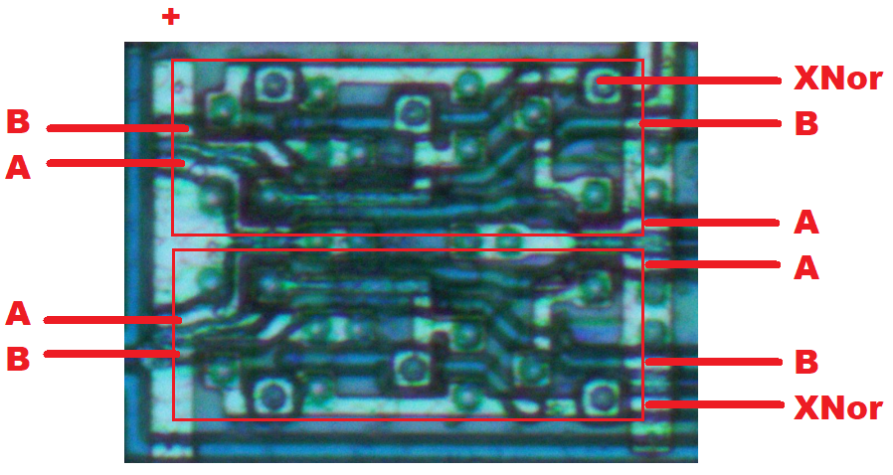
Xor 2

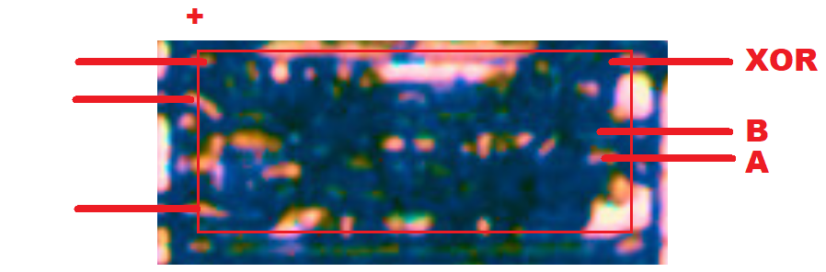

Note: Cells B47,B72,B80 give XOR logic instead of XNOR. The XOR cell appears horizontally flipped with respect to the power rails. All XORs take their output from the side that has the more distant via (- rail side). All XNORs take their output from the side with the closer via (also the - rail side). So, XNOR vs XOR may be totally differnet cells that are flipped respect to the rails (likely), or they may be the same cell that gives XNOR vs XOR depending on the side used (unlikely).

OAI2

There are only 5 of these:
A12, BH29, BK46, BK51, BK89

It is possible that this isn’t exactly correct. I believe I have a consistent ABCX mapped out on each one, but it may still be possible that ABC inputs aren’t mapped to this diagram correctly:

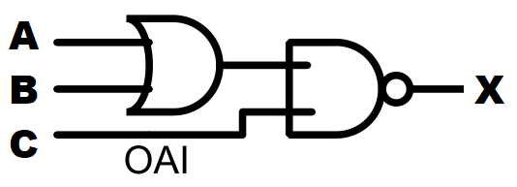

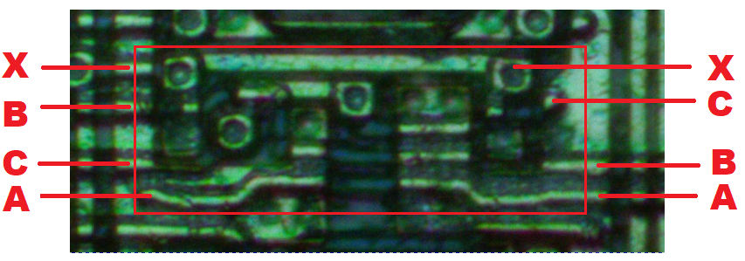

And-Or-Invert “AOI 2”:
(This was referred to as “unknown 4-to-1” on the original schematic.)

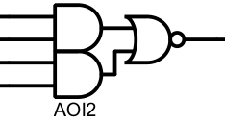
A
B

C
D

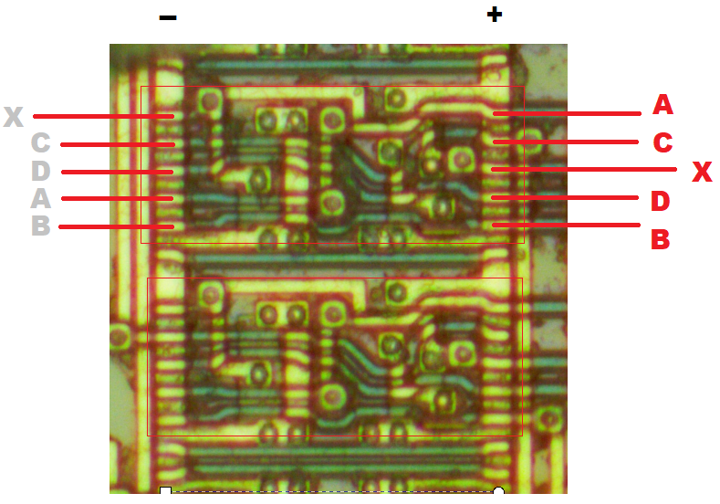

Unknown 2 to 2 combinational logic cell

Used at locations C36, C41, E37, H83.2

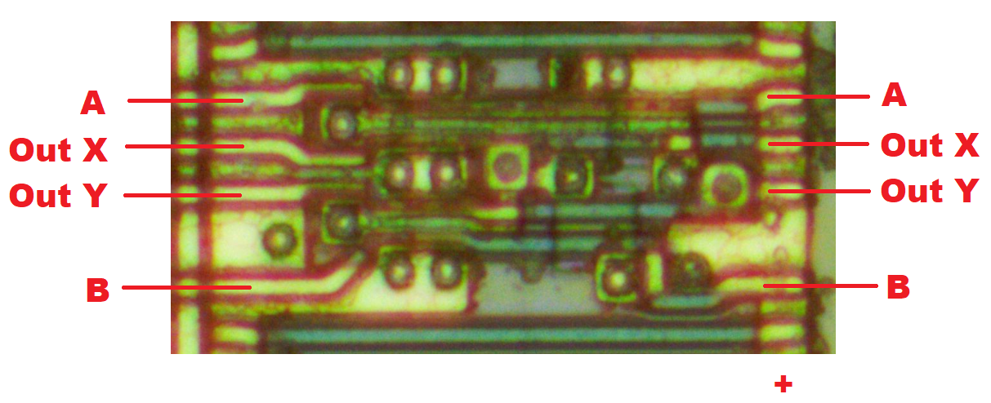

3-State Buffer

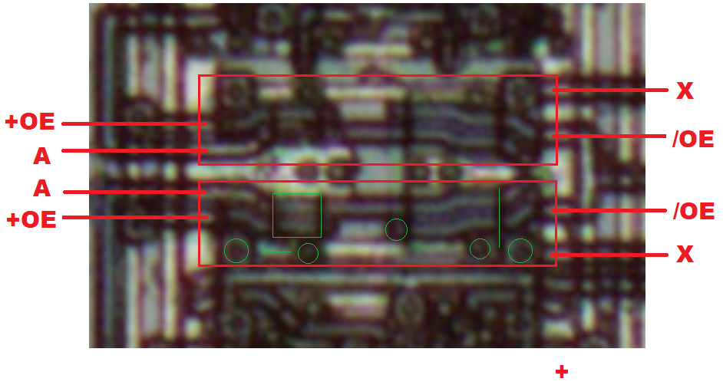

Tracing style good example (below)
A input is long and bent, X output is straight
/OE input long, +OE short

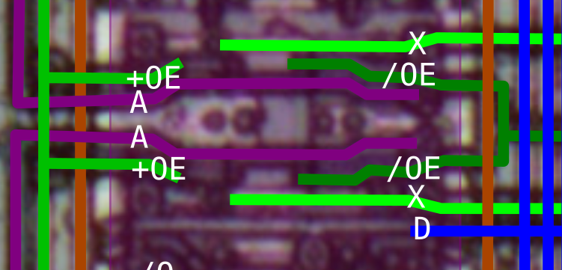

D-FF Reset
Asynchronous reset to Q = 0.

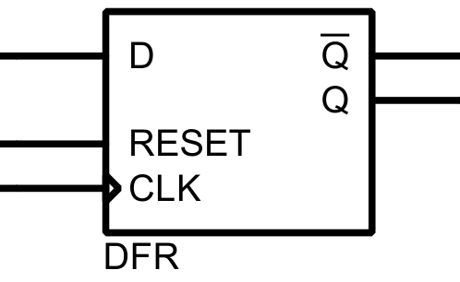
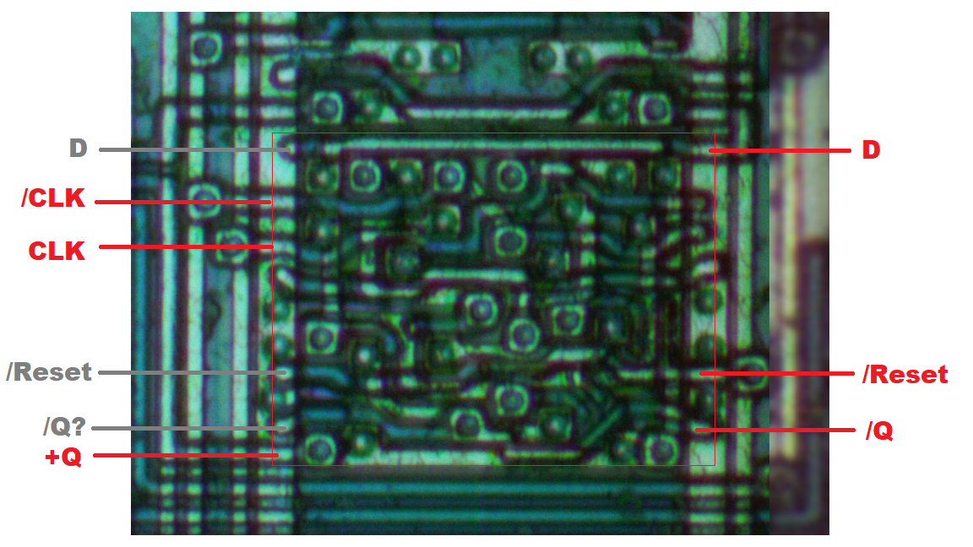

“D-FF Set”
Reg2 (V-Design)
Asynchronous set to Q=1
Note: clock polarity is not reversed on 1 side vs the other like most other flip-flops.

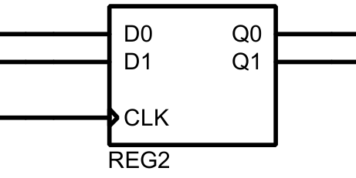

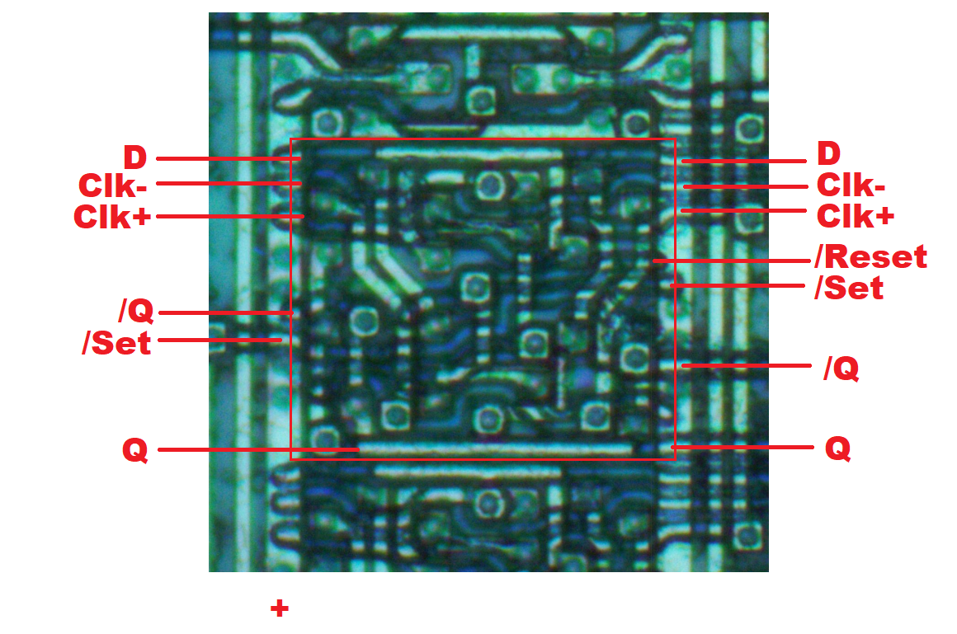

D-Latch (“LatchN” on schematic)
Does not have reset

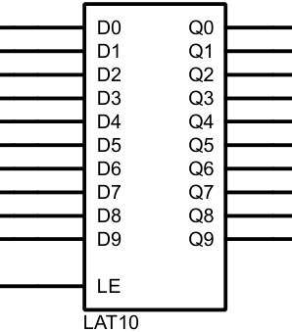

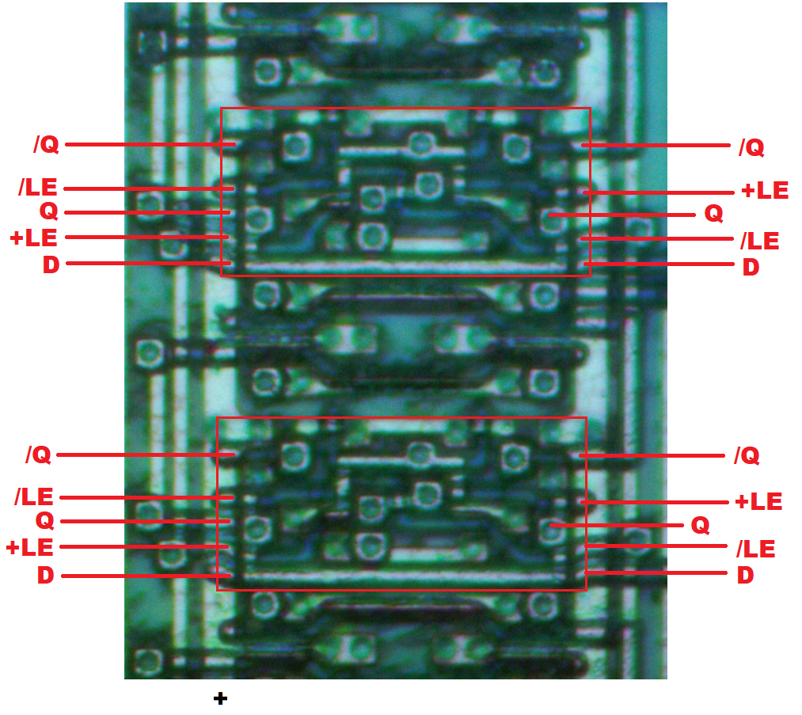

D-Latch with Reset (Latch[n]R on schematic)
Asynchronsous reset
Unknown reset value

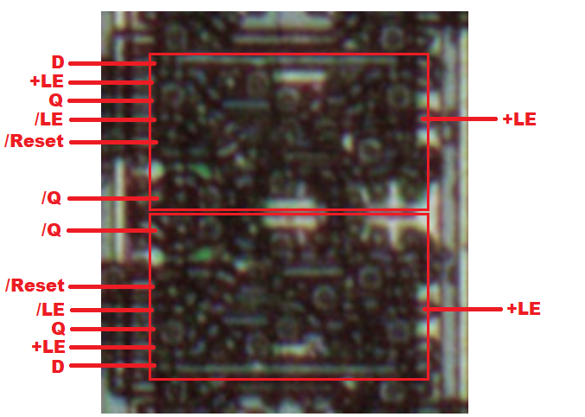

SR Latch

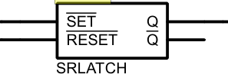

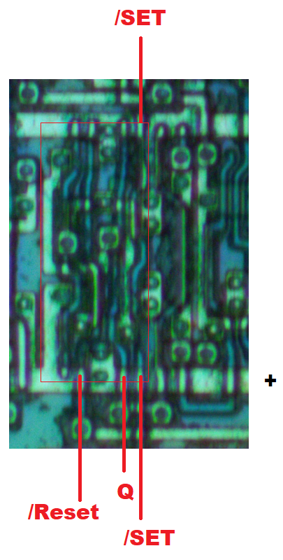

D-FF without reset, “JL” design

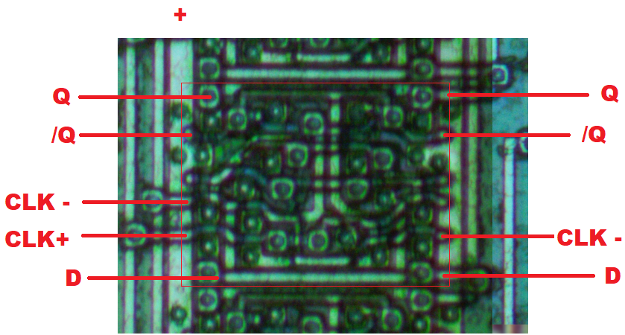

T-FF Counter Element (“P-Flag” Design)
This variation without preload input.
Synchronous Reset to Q=0

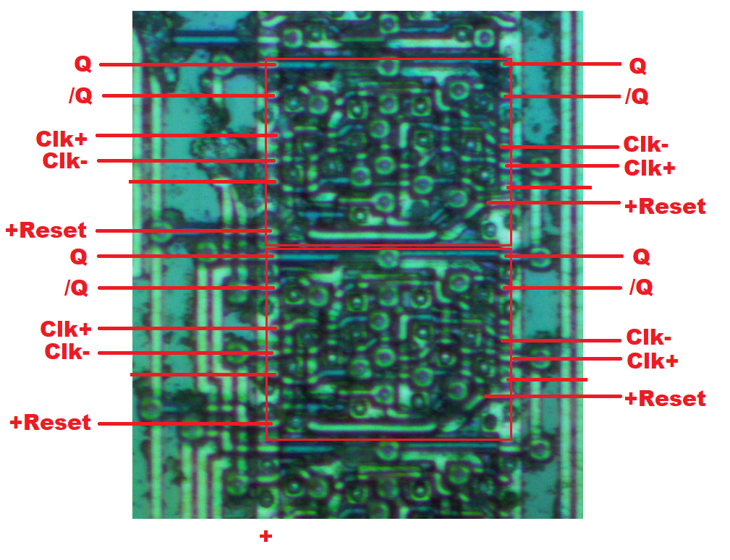

T-FF Counter Element (“P-Flag” Design)
This variation with asynchronous preload input.
P → Q when +Load = 1, asynchronous to clock.
Not sure of P→Q is transparent with a level-based +load or latches at the rising edoge of +load.

Notes: ‘+load’ MUST be asynchronous to the clock despite ‘+reset’ being synchronous on the other variation, due to the way V-Split counter can reload without any clock pulse possible on the upper bits. Additional logic is sometimes built around +load combining P and +load. I don’t know the purpose of that.

Possible alternative thoughts where it could still be synchronous: The synchronous preload on the first one, changes Q, which immediately ripples into the next one’s clock input. It may be able to ripple through all of the counter elements in this way and remain synchronous. Because the PPU fetch counter in column S uses a mixture of the preload and reset variations, it could be explained by this rippling preload/reset theory.

Identification of this preloadable variant:
- The entire cell is 1 unit taller.
- The via in the center between the 2 Qs looks different.

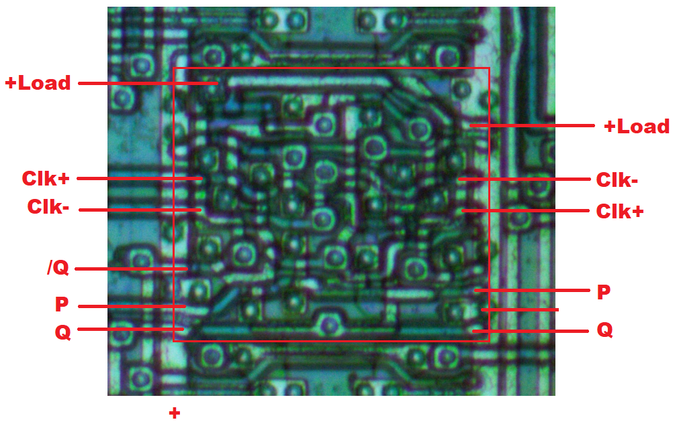

D-Flip Flop with /Set and /Reset

I really do not know how this works, there are only 2 of them: R5 and T4.

- R5 controls when PPU fetches increment the fetch counter.
  - Note: This operates on PPU Fetches; i.e. once per 2 PPU cycles.
  - /Reset and /Set make sense
  - D, coming from S16: The specific fetch count doesn’t make sense, something probably wrong with S16 or the traces getting to S16.
- T4 controls when a detected V-Split scanline should cause a reset to the V-Split scanline counter.
  - Note: This operates on scanline counts; i.e. once per whole scanline.
  - /Reset makes sense, when scanline is 239 and we are not rendering in frame, /reset gets triggered. This makes /Q=1, which allows reload for the next v-split scanline detected.
  - /Set, the logic is simple, but I can’t make sense of it. It uses the unusual OAI2, which may not be understood correctly.
  - D makes sense. When scanline is 239, D=0, so this makes /Q=1, allowing the counter to reload. In all other scanline values, D=1, making /Q=0, preventing counter reload.

Based on the combination of the parts I think I understand:

